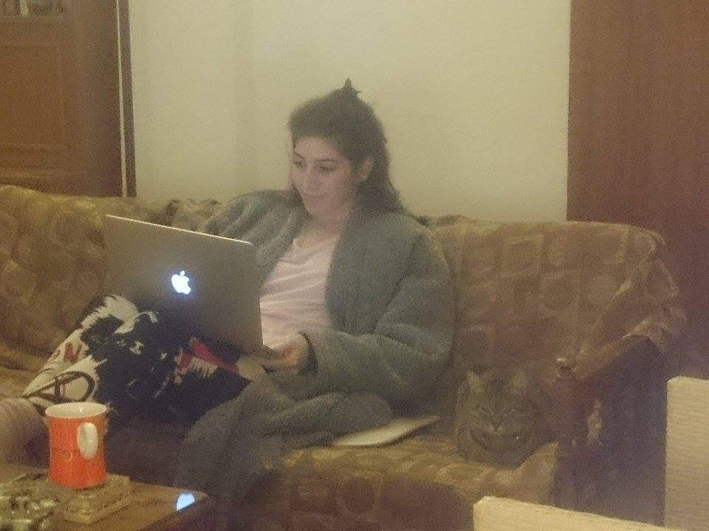

A conversation between Peter Eramian and Heejoon Lee about Prehistoric Loom.

HJ: The idea of the show was triggered after coming back to Seoul, my hometown, after finishing 2 years of study in far away Glasgow. First, I thought 2 years away from where I grew up would be a small change and coming back would be the same 'me'. But I was transformed, totally. I brought something back from Glasgow, a network, a network based on friendship. This show is organized to examine the bond between the people I met during my time in Glasgow. It is to understand the network that we built unconsciously, more like naturally, by being at the same place in the same period with a similar purpose. We may have come from different backgrounds and our values may be different, but our shared interest in art and the desire to learn and experience new things integrated us into a unique micro-society. Even though we have now spread into different directions, because of many practical reasons, the network that we built is real and still stands among us. The show itself is living proof of the network and also is a signpost to many future possibilities.

PE: Networking and intermixing cultural perspectives is certainly a most valuable experience. The super celebrated cosmopolitanism of the modern world, the advancements of technology that allow us to keep in touch online but also to travel easily from one side of the world to the other, and the new exciting possibilities such encounters present lay out a spectrum of creativity that almost touches upon infinity. However, I'd like to challenge this enthusiasm a little by asking you the following questions: What if the individuals you had met in Glasgow were different people? What if you had not clicked with them? Would you have still created this network? My point is, perhaps instead of celebrating the 'networking' angle to this friendship (a marketing term increasingly used by global corporations and social media), what should be celebrated is the 'miracle' of friendship, an event which is happening less and less possible in today's busy career-focused world. 'Networking' alone does not offer such miracles, it is also a matter of good fortune. For it is an unfortunate truth that modern anxieties and fears are making it more and more difficult for people to connect; a lot of people are either too busy, too tired or too depressed. This is especially true in the busiest and largest cities, which are often also the loneliest. Facebook 'friends' are not friends, they are a cheap substitute, a marketing ploy which deceives and exploits your emotional psyche in order to hold on to your consumerist attention. What I'm saying is, let's rethink what the term 'friend' means. In my dictionary, it can only mean miracle. It is not something we can take for granted or attribute to any mechanism outside the friendship itself.

HJ: Yes, I agree with your perspective that friendship is something that comes prior to the concept of network that you mentioned. It is a priceless relationship, especially in a world where social networking is dominating our lives. However, I think friendship doesn't just happen by luck, but via a situation, purpose and time. The period that we were all in Glasgow was a situation that, in a way, forced us to be friends even though we had different characters and personalities. But with respect and trust towards each other, we were able to communicate and become friends. The cultural barriers and differences in ideology were a challenge, but more like a fun quiz challenge that we all wanted to solve. Also, in terms of purpose, we shared the fever of art. Our obsession for contemporary art formed a shared space where we could lay down our prejudices and habits and allow new perspectives into our minds. To rediscover ourselves as 'not the same me'. Finally, these two years allowed us to interact, discuss and produce; to share not just academic knowledge, but also emotions and feelings. Thus, by admitting our differences, we became friends.

PE: For me it's important to see this 'happening' of friendship as an isolated phenomenon and not as the result of a means. Because if one focuses too much on the 'how', it can easily be exploited to sell the idea/package/service of a way/method to 'friendship' – but that is precisely what friendship is not, friendship is not a means it is an end! It doesn't matter what the means is, no means can produce a friendship. All I'm saying is, however easy it may have become today to stay connected with each other or travel, such means ultimately mean nothing. You were fortunate enough to find this special relationship via your experience in Glasgow, but this does not mean that anyone who travels to Glasgow under similar conditions will also find it. In fact, I would say the only conditions categorically necessary for friendship are internal, not external, such as inner spiritual and mental health, goodwill, and so on. As you pointed out, the respect and trust you had for each other made you forget your differences, it was the foundation of your friendship. Another point I was thinking is that friendship is akin to a creative act, it cannot always be understood rationally. There is a mystery to how friendships are formed. Out of the thousands or millions of people you might encounter in your lifetime, somehow you click with only a few and they become like family to you. It almost feels like destiny, you can't really make sense of it besides just saying 'it was meant to be'. There may not be any cultural compatibility, physical logic or psychological reasoning whatsoever; it just unpredictably happens, like falling in love. This is unlike the 'institution' of family, which conforms to predictable socially constructed notions grounding its essence in blood, disallowing any metaphysical magic and attributing the value of the relationship to biological causality.

HJ: It is an interesting view that friendship can be seen as an 'idea/package', since what surrounds us in the modern day are mostly 'products'. We should definitely be aware not to depreciate one of the most precious values of the human race. Therefore, I would like to speak about how friendship can be fragile in some cases. How it needs to be maintained and continued. There are many ways that a friendship can break and become as if it meant nothing. For example, because of misunderstandings that commonly occur in our daily lives. But besides that, I am more worried and aware of time and distance. Time devours and swallows everything in the world. It decays shinning metal into rusty ash and also blurs our memories. What does it mean for the memory of a relationship to grow fainter and fainter? Does it just dramatize the memory and make it feel nostalgic? Also, can friendship be the same when the physical distance between friends is more than it used to be? Can friendship be something that overcomes all obstacles and exists as an immortal bond? I am personally a bit pessimistic about friendship lasting forever. However, above all, what is interesting is that the fragility of friendship may be the very thing that makes it attractive and valuable. But in any case, it is important for us to be aware of the fragility of friendship because it needs to be continued.

PE: I agree that fragility is an important element to friendship. In fact, I think some of the most valuable things in life are often the most fragile and most powerful at the same time. It's a peculiar, poetic, tension. But this is also why we have to be careful not to be over-possessive of friendship. Like love, it is a shared experience that should strengthen each member. Since circumstances and contexts change, so may the form of a friendship, this does not mean there is any less love. There needs to be a bond that is both firm and flexible, deep and light. If one holds on to a loved one too hard they endanger their freedom, like a caged bird, the point is lost. In fact, in some cases making peace with the fact that you can't be in communication with each other for a while, or even ever again, may be an act of friendship in itself. Letting go is just as important as holding on, according to the circumstance. This is unlike Facebook and social networks, which desperately expect you to transcend all circumstances and hold on to every single 'friend' you make, forever, within the 'cage' of your profile. I prefer to think that friendship is something that should be appreciated in the moments when it happens, for as long as that may last (whether it's just a few minutes, days, months, years or a lifetime – it doesn't matter). We should not fearfully idealize friendship and try hold onto it by containing it within a mould or frame, which ultimately only limits its infinite nature. On the other hand, this may sound like an exaggeration, I think an act of true friendship is the closest we can ever be to God. It is an unfortunate fact that God is often represented in most religions as a father-figure with authority and power. In my understanding, God can only be an equal friend. If God was modelled on friendship hierarchies wouldn't exist. Instead God would be understood as simply that respect and trust you mentioned earlier, which can potentially be found in all of us, no matter what context or circumstance.

HJ: As you know, many people have already spoken about the differences between the relationships of friends and lovers. Lovers tend to show a more possessive attitude to each other, whether they are 'cool' or not. Friends may seem less tight than lovers, but they are also less possessive and more flexible. It is like a memory spring which can stay in different shapes depending on the 'temperature'. But in the case of lovers, the relationship is more like a furnace, it heats up crazy and may explode. The object made from it can quickly cool down like ice but when it receives a strong blow from the outside it can easily crack. No flexibility. Thus, friendship is an interesting powerful bond with flexibility that one can enjoy. Coming back to the show, the medium I'm proposing for the networking of friendship is drawing, which has a very long history that goes back to prehistoric times. The first evidence of civilization is often proven by drawings found on cave walls and animal bones. The show explores what it means to network friendship with something as primitive as drawing in a world where complex new technologies are all around us; and to see if it can affect the friendship and potentially grow it into something new.

